**Model: A Real-time Merging Pattern Control Model(标题直接就写Merging Pattern)**

Here, we devise a real-time merging control system for toll plaza based on the precious work by M. Papageorgiou et al. Through our improvement, it can be specially used for the toll plaza we are discussing. In addition, this system can effectively maximize the throughput by maintaining the occupancy of departure area close to a critical value. Figure 1 illustrates the framework of this system.

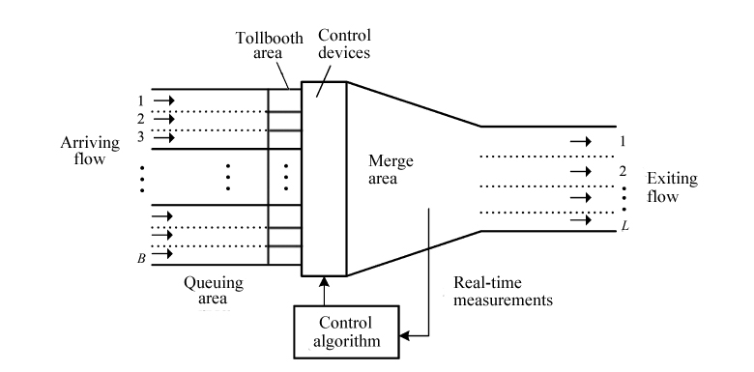

Figure 1

**Elements**

**Merge area**

As a matter of fact, the merge area is equal to the departure zone as referred to above. Typically, it is an approximately trapezoidal area where the vehicles leave from the booths on a total of *B* lanes and finally fit into L lanes of the exit. Here, we focus on the flow-density variation with the occupancy increasing in the merge area. Eventually, we obtain a diagram to describe this functionary relationship, which is shown in Figure 2.

插入我们做的图

Figure 2.

After noticing that X-axis is occupancy *o* (%), while Y-axis represents the exit flow *q_out,* we can tell from the diagram:

* When *o* is small, merging conflicts are scarce, and the exit flow is correspondingly low.
* As *o* increases, merging conflicts may increase, but *q_out* also increases as well until, for a specific value *o_cr*, the exit flow reaches the capacity *q_cap.*
* If o increases beyond *o_cr*, merging conflicts become more frequent, leading to a serious congestion. Consequently, a capacity drop happens.

Therefore, we can conclude that the occupancy of the merge area can directly influence the exit flow, or rather, the throughput. And we can regulate the occupancy under the goal to maintain o 约等于 o_cr by controlling the merging pattern with the assistant of a control algorithm and feedback. From a macroscopic perspective, the maximum throughput can be achieved by a certain merging pattern design. As a result, our goal to model this design.

**Feedback control based on ALINEA**

We are inspired by a scheme from a previous article *(Real-time merging traffic control with applications to toll plaza and work zone management,2008)*, and decide to deploy traffic lights to individual lanes as control devices.

However, the most crucial task is to determine the form of feedback control.

We suppose that the feedback control is activated at each discrete time interval. After activation, it will collect latest measurements of occupancy o, and send data-converted instructions to control devices under the purpose of maintaining o 约等于 o_cr. Thus, we choose to apply ALINEA as our control algorithm.

ALINEA can be expressed as:



Where,

n The discrete time index

q(n) The controlled entering flow (veh/h) to be implemented in a new time step n

q(n-1) The existed entering flow (veh/h) in last time step

o(n-1) The measured occupancy of merge area in last time step

o^ The desired value of occupancy (can be set as o_cr)

K_R A regulator parameter, always positive

In addition, the occupancy measurement should best be placed at or just upstream of the location where serious vehicle decelerations （congestion） appear first.

后面可以再加PI 控制和测试结果